English brand
Brand equity= capital de la marque (notoriété)
- Forces/faiblesses on peut les contrôler
- Opportunités/menaces on ne les contrôle pas mais influence nos affaires
Brand levers = levier de marque
Motto= devise

Brand culture is the set of shared values, beliefs, behaviors, and symbols that shape how a brand is created, expressed and experienced by all its stakeholders both inside the organization (employees, leadership) and outside (customers, partners, communities).

It I the “personality” of the brand, reflected across :
- What the brands stands for (vision, purpose, missions, values)
- How it acts (customers interactions, employees behaviors, buisness decisions)
- How it communicates (tone, storytelling, symbolism)
- How it is perceived (reputation, associations, customer experience)
3 composantes d’une stratégie (component of a strat ) dans une boite (in a company) :
- Vision
- Mission
- Values
Ex : Google : The brand culture of innovation and openness, expressed in its playful tone, internal work culture, and product design.
Harley-Davidson : Brand culture of freedom and rebellion, reinforced through its biker community and lifestyle positioning.
The brand I value creation
- Brands have envolved far beyond simple logos and slogans
- They represent value-creation
Source of brand values
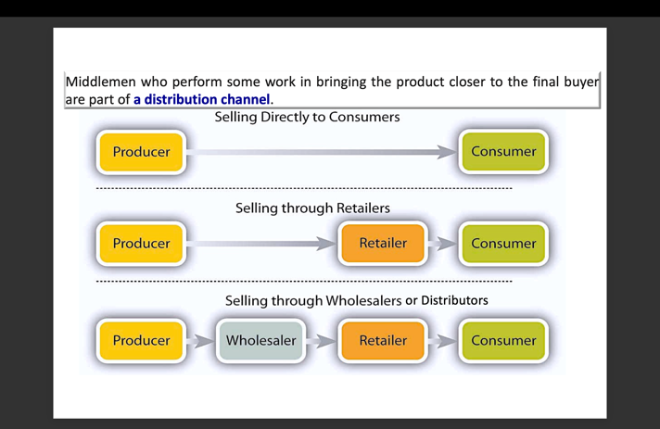

Retailer = détaillant
Wholesaler = grossiste
3 types of disyribution
- Intensive = product that you. Can find everywhere
- Selective = selective stand in a resale store (Longchamp Galeries Lafayette)
- Exclusive= living brand culture -> premium prices (Rolex)
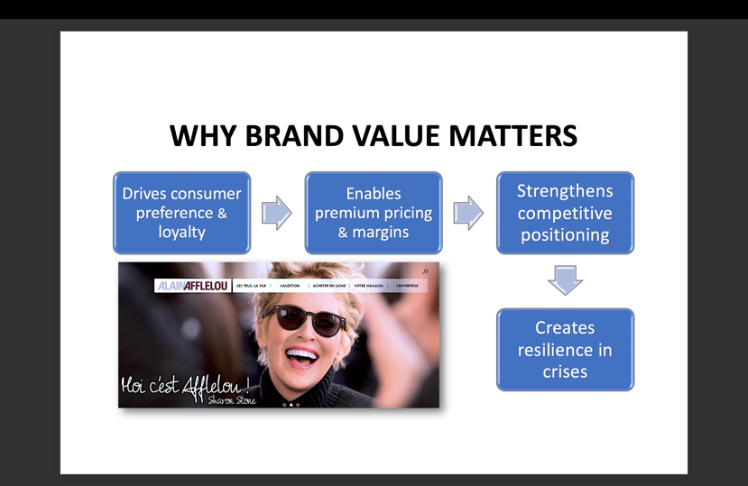
Why brands value matters?

CA= competitive advantage
USP = unique selling proposition
- You want it to be as sustainable as possible

- MANUFACTURERS, SOURCES OF BRAND VALUE:

Product Quality & Innovation: Delivering superior performance or innovation builds trust and loyalty.

Brand Equity & Recognition: The strength of their brand name translates into customer preference and pricing power.

Heritage & Storytelling: Long-standing history or strong brand narratives create authenticity.

Marketing Investment: Brand-building campaigns, endorsements, and sponsorships reinforce brand presence.

Intellectual Property (IP): Trademarks, patents (brevet), and design rights protection.
Marketing = creation of values
Ex : Apple : Creates value through product design, software integration and innovation. It’s powerful brand equity allows apple to command premium pricing and expand into services (Apple Music, iCloud).
Quality message : Gerblé
- Promesse : aliment sain
- Preuve : expert de la diététique
- Bénéfice : Le conso mange sain il le sait
- Ton : Ton de l’expert et du conseiller

- Manufacturer, Distributor, Retailers et consumers : ex Tesla

- Through their website, Tesla shares about its intern politics. In what concerns Tesla’s manufacturing, the company started its manufacturing program in 2012 with their Model S rolled off the assembly line at their factory in Fremont, California. Today, they have the capacity to manufacture more than a million vehicles every year, in addition to energy products, battery cells and more. So, manufacturers are Tesla’s factories in the USA, Germany and China.

- About their distributors, the company is able to be sold worldwide. Indeed, their products are available in proper Tesla concessions or in reseller stores all around the world. However, some laws and local policies are going against Tesla distribution program, as an example, the Cybertruck is forbidden to sale in the European Union due to security issues.

- In what concerns retailers, Tesla does not rely on independent retailers or dealers. That means that Their stores as much as the Tesla service centers handle the selling and the testing of vehicles while handling maintenance and technical support.

- Finally, Tesla’s end consumers include individual consumers, businesses, governments and institutions.

- In a nutshell, the company pretty much handles the entirety of their supply chain, from the manufacturing to the consumers.
Hermes = flagship store car vitrines pour les marques
Retailer -> GRC (en français) = consumer relationship management
Manufacturer: builds brand equity through innovation (EV’s) : Tesla is D to C (direct to consumer -> automatic technology)
Retailer: tesla’s retail store : consumer’s experience (elevate the premium brand perception)

Consumer Act as a brand evangelist, sharing experiences online strengthening the community and adding credibility.
Distributors : tesla bypasses traditional distributors with direct to consumer channels, reinforcing exclusivity.
- Distributors sources of brand value
Association with strong brands : distributing well-known brands enhances their credibility
Reliability and Trust : Delivering brands to market builds reputation with both retailers and manufacturers
Exclusive distribution rights : being the only distributor of a brand generates bargaining (négociation) power. = avoir le monopole et donc avoir le pouvoir de négocier (5 forces de Porter)
Market coverage and reach : the ability to make a brand available across countries adds values
After-Sales support : providing warranty or technical support strengthens brand reliability
- Retailers sources of brand value
Shelf Space and visibility : Premium placement in store or online boosts brand.
Customers experience : a retailer’s ambiance, service quality, and digital UX (user experience) elevate the perceived value of brands they carry.
Private Labels and co branding : reailers create their own brand value
MDD = private labels (genre marque carrefour -> moins cher pour éviter problème de distribution car ce sont des marques de distributeurs)
Consumer trust and loyalty programs : strong retailer brands (sephora) amplify the brands they sell.
Ca = sustainable
Rarefaction = réduire l’offre pour rehausser les prix (=scarcity)
Ex : sephora (retailer) : elevate luxury beauty brands by providing experiential retail
4 positionnement d’entreprises :
- Leader
- Challenger
- Follower
- Nicher

4. Consumers, (end-users, decision-maker)
- Percceived quality and status : the brand image (luxury, eco-friendly,affordable) drives personal identity expression
USP = unique selling proposition
Emotional connection : stories, values, and social causes resonate and build loyalty.
Word of Mouth and social proof : positive reviews, social media posts and influencer advocacy amplify brand equity
Community and Belonging : some brands foster tribes
Nike : nike’s brand value grows as consumers embrace it not only for product performance but also for identity.
Empowerment
Don’t in brand names :
- Difficult to spell
- Hard to pronounce
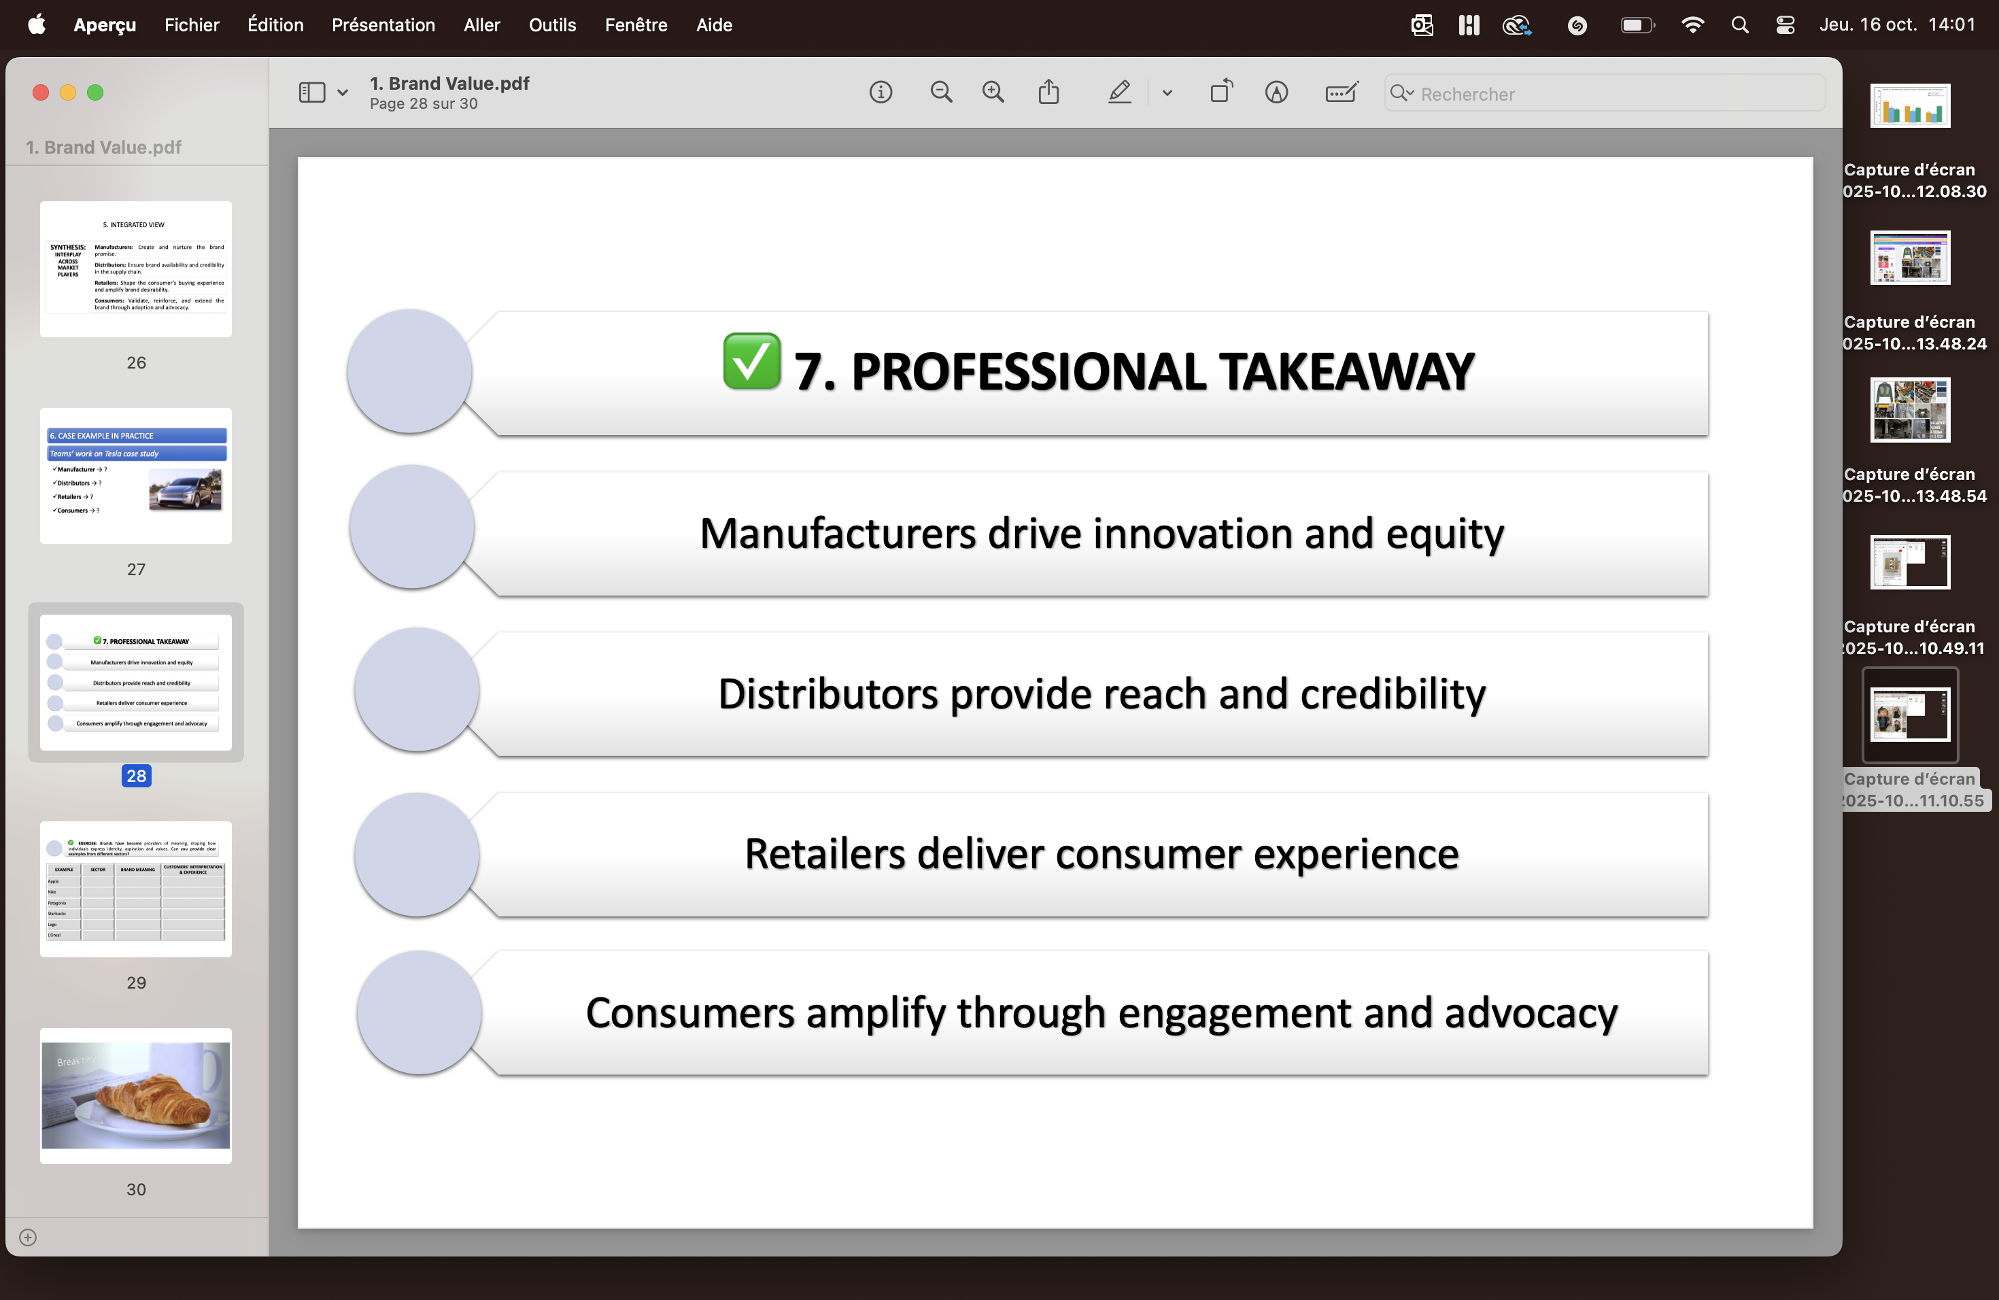

Apple évolue dans le secteur de la technologie. La marque incarne l’innovation, le design, la créativité et la simplicité. Les clients perçoivent Apple comme un symbole de modernité et de statut, et apprécient une expérience intuitive et premium.
Nike, dans le secteur du sport et de l’habillement, véhicule des valeurs de performance, de dépassement de soi et de motivation, illustrées par son slogan “Just Do It”. Les consommateurs ressentent une confiance en eux et un sentiment d’appartenance à une communauté active et gagnante.
Patagonia appartient au secteur de l’outdoor et de l’habillement. La marque se distingue par son engagement écologique et sa responsabilité sociale. Les clients interprètent Patagonia comme une marque éthique, et leur expérience traduit un choix de consommation responsable et durable.
Starbucks, dans le domaine de la restauration et des boissons, associe sa marque à des notions de communauté, de confort et de personnalisation. Les clients perçoivent Starbucks comme un “troisième lieu” entre le domicile et le travail, offrant une expérience chaleureuse et personnelle.
Lego appartient au secteur des jeux et de l’éducation. Son sens de marque repose sur la créativité, l’apprentissage par le jeu et l’imagination. Les consommateurs vivent une expérience ludique et éducative, mêlant plaisir, imagination et nostalgie.
L’Oréal, dans le secteur de la beauté et des cosmétiques, met en avant des valeurs de confiance en soi, d’inclusivité et de glamour, portées par le slogan “Parce que vous le valez bien”. Les clients associent la marque à l’estime de soi et à l’expression personnelle, tout en profitant d’une forme de luxe accessible.

PART 2 :
- Brand culture vs Corporate culture
- Corporate culture : The internal environment of an organization
- Brand culture : The externalized identity of a company.
- Focus
- Corporate Culture: Employee experience, organizational structure, decision-making,management style.
- Brand Culture: Customer experience, brand promise, marketing, storytelling, and how the organization shows up in the marketplace.
- 3. AUDIENCE
- CORPORATE CULTURE → Primarily internal stakeholders (employees,managers, leadership).
- BRAND CULTURE → Both internal and external stakeholders (customers,employees, partners, communi9es).
- 4. DRIVERS
- CORPORATE CULTURE → Driven by leadership values, HR policies, internal norms, oﬃce environment.

- BRAND CULTURE → Driven by brand purpose, consumer expecta9ons, market positioning, and cultural relevance.

5. OUTCOMES
CORPORATE CULTURE → Impacts employee engagement, productivity and
innovation.
BRAND CULTURE → Impacts consumer perception, loyalty, advocacy and brand equity.

Ex : pantagonia = corporate culture et brand culture

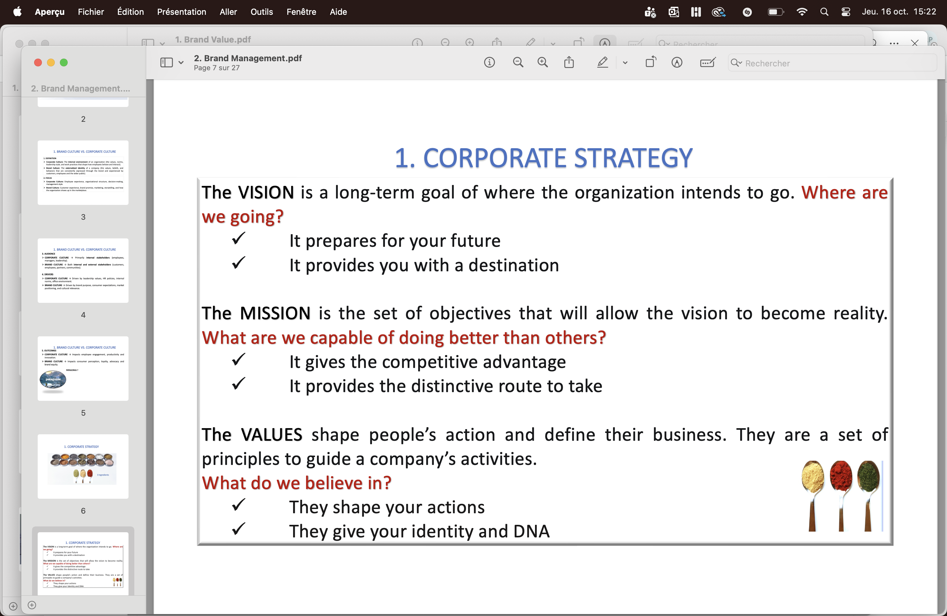

Ex : Amazon

- THE BRAND LIFE CYCLE

INTRODUCTION: Build awareness and identity (e.g., Tesla early years).

GROWTH: Expand market share and loyalty (e.g., Apple iPhone adoption phase).

MATURITY: Maintain differentiation and emotional engagement (e.g., Coca-Cola).

DECLINE / RENEWAL: Rebrand or reposition to regain relevance (e.g., Burberry).

Each stage demands tailored communication, investment, and innovation strategy.

NAVIGATING LIFE CYCLE CHALLENGES :

- INTRODUCTION introductions require clear value propositions, target audience identification, and marketing campaigns. Research shows 95% of new products
fail due to poor brand positioning and market misalignment.
- GROWTH During growth phases, brands must balance expansion with consistency. KPIs include brand awareness, consideration rates, and customer acquisition costs.
- MATURITY Mature brands focus on loyalty retention and profitability optimization. Strategies include premium positioning, brand extensions, and customer lifetime value maximization.

BCG

BCG matrix assumes that profitability and market share are highly related.

A useful approach for making business decisions.

An analysis on products according to growth and relative market share.

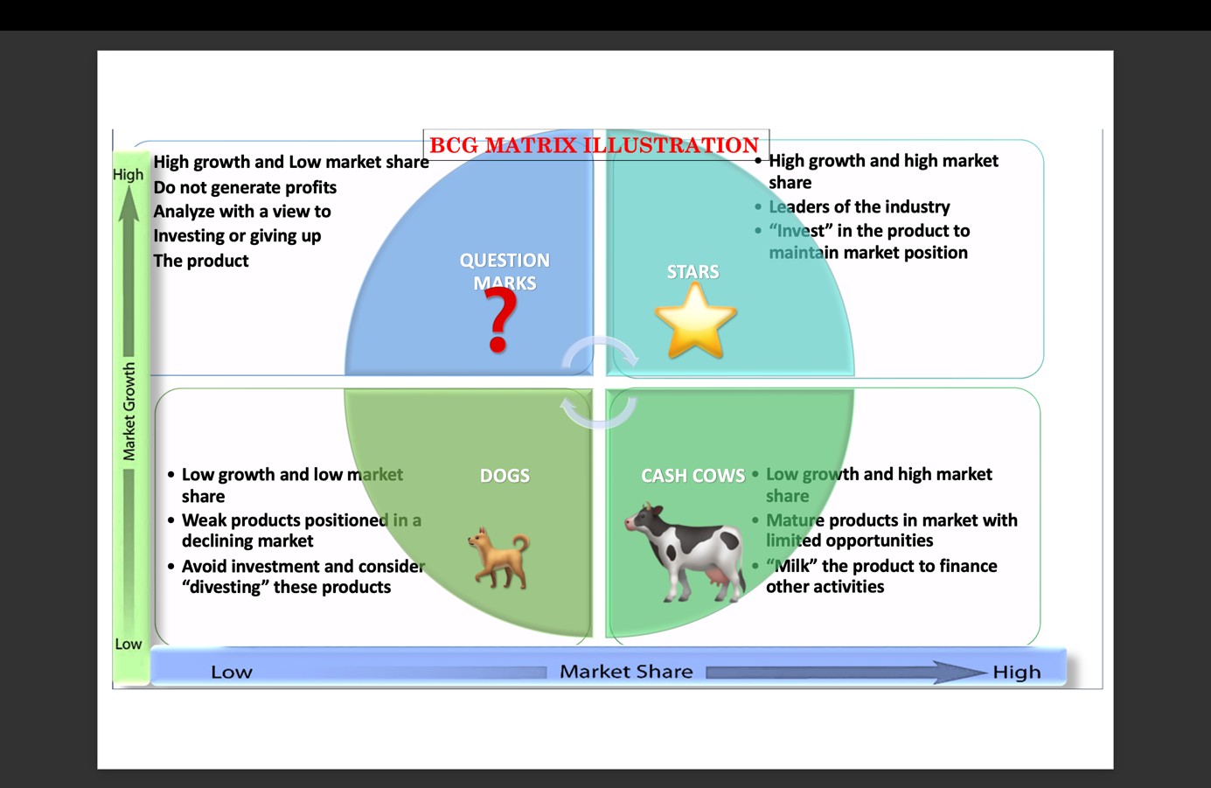

Exercice d’application avec Nespresso :
BCG Matrix – Nespresso Europe
Unit chosen (Portfolio):
Nespresso Europe – including the home consumer lines (Original and Vertuo) plus the Professional (“office / business”) channel.

Market overview:
The European coffee-pods & capsules market is sizable and growing: for example, valued at about USD 17.09 billion in 2025 with a CAGR of ~6.4% according to one source.
Europe is a key region for Nespresso, and the global Nespresso capsule market shows Europe accounting for over 30% of revenue in one estimate.
In addition, for Nespresso globally the Original Line held about 58% share of the Nespresso business in 2024.
Assumed data for Europe unit:
Market share of Nespresso Europe: 25% (as per your scenario)
Market growth rate (European capsules/pods): ~5.7% (as per your scenario)
Relative market share: If Nespresso holds 25% and the market leader holds say ~30%, then the relative share ≈ 0.83 (25/30) → less than 1, so Nespresso is a significant but not dominant player.
Product lines & positions:
Original Line
Share: part of the 25% overall; globally it represented ~58% of Nespresso’s business.
Growth: in a market growing ~5.7% in Europe, but this mature line likely grows slower than the market average (given its already-established status).
Position: Because original has strong share but slower growth, it tends toward a “Cash Cow” type — it generates steady revenue but less explosive growth.
Original Line
Key competitors: L’OR (by JDE Peet’s), Lavazza capsules compatible, Illy with its X-CAPS system. These brands compete on the premium capsule segment, often offering lower prices or compatible systems.

Recommended action:
Focus on maintaining profitability, strengthen customer loyalty, optimise cost structure, manage brand premium status. Invest selectively in sustaining the line (limited editions, sustainability credentials) rather than aggressive expansion. Use the cash flow from this line to support higher-growth segments.
Vertuo Line
Share: part of the Nespresso portfolio aimed at growth/new segments (larger cups, new machine format) though exact share in Europe not specified in the data we have.
Growth: Because Vertuo is newer and positioned for expansion, in a market growing ~5.7%, it likely has higher growth potential (and indeed the global results say “Vertuo continued to deliver very solid performance with positive growth across all geographies.”
Position: With moderate to high growth potential and still building share relative to the leader, this line falls in the “Star” (if share is already high) or “Question Mark” (if share is still below leader) category.
Recommended action:
Invest significantly: marketing push, distribution expansion, machine-offer incentives, bundle offers, push into new consumer segments (younger, convenience-oriented). Aim to increase share and turn Vertuo into a dominant growth driver.
Share: This is the more niche professional segment of Nespresso Europe (office machines, hospitality, etc). We have a pointer that in one breakdown the Professional channel represented ~19% of Nespresso’s business in a sustainability-report breakdown (Original line ~46%, Vertuo ~35%, Professional ~19%).
Growth: The business channel might grow differently than home consumer. The overall market growth ~5.7% gives a baseline; business channels may be slower or more volatile depending on office recovery, hospitality sector.
Position: With lower share and variable growth potential, this channel likely resides in the “Question Mark” zone: moderate growth market but share not dominant.
Recommended action:
Choose carefully: if the professional segment shows strong margin and growth potential, consider investing to grow the share (e.g., service contracts, subscriptions, eco-friendly office solutions). Otherwise, if growth slows, consider shifting resources away or treat as niche with stable returns.

Professional
Share: This is the more niche professional segment of Nespresso Europe (office machines, hospitality, etc). We have a pointer that in one breakdown the Professional channel represented ~19% of Nespresso’s business in a sustainability-report breakdown (Original line ~46%, Vertuo ~35%, Professional ~19%).
Growth: The business channel might grow differently than home consumer. The overall market growth ~5.7% gives a baseline; business channels may be slower or more volatile depending on office recovery, hospitality sector.
Position: With lower share and variable growth potential, this channel likely resides in the “Question Mark” zone: moderate growth market but share not dominant.
Recommended action: Choose carefully: if the professional segment shows strong margin and growth potential, consider investing to grow the share (e.g., service contracts, subscriptions, eco-friendly office solutions). Otherwise, if growth slows, consider shifting resources away or treat as niche with stable returns.
Strategic implications (overall): Given Nespresso Europe’s market share of ~25%, in a market growing ~5.7%, the business unit is well positioned in a growing market but not market leader. The overall umbrella position is between “Star” and “Question Mark”. The key is to lean into growth (especially via Vertuo and Professional), while leveraging the strong and profitable Original Line to fund expansion and innovations. Monitoring market dynamics is vital—if growth slows, the Original Line may shift into “Cash Cow” territory and the business may need to focus on efficiency and cash generation rather than expansion.

Exo apple :
- Brand Architecture

Types of brand architecture :
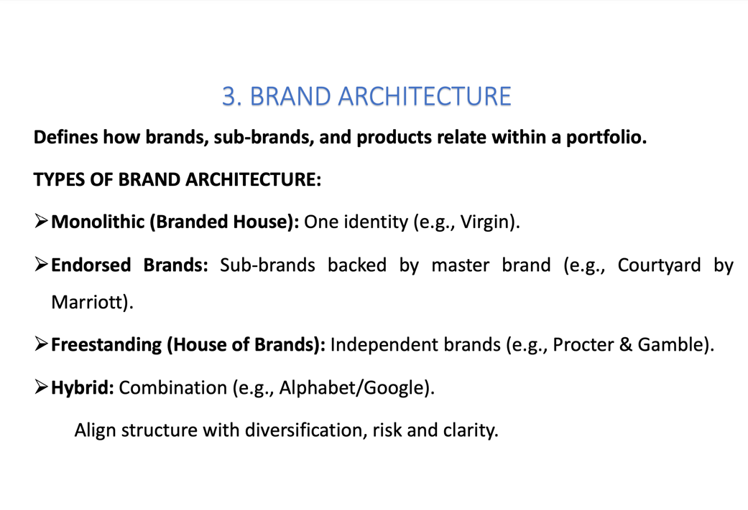

Ex : Mariott
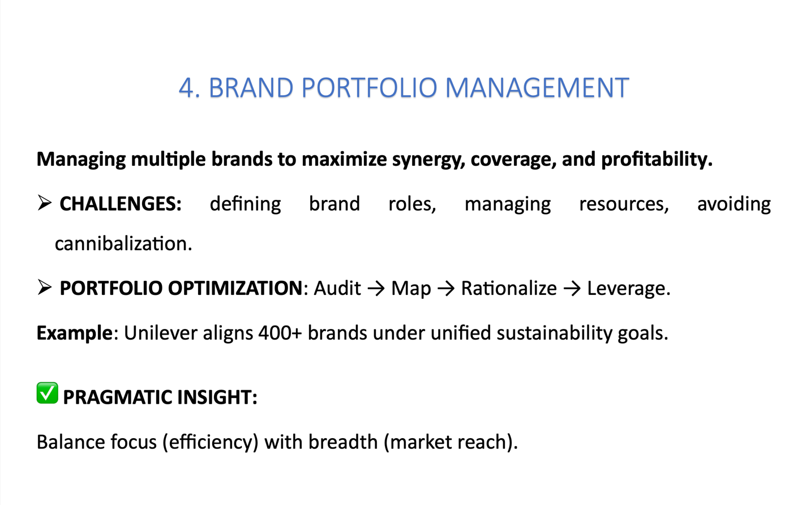

Dmd 5 : e-reputation

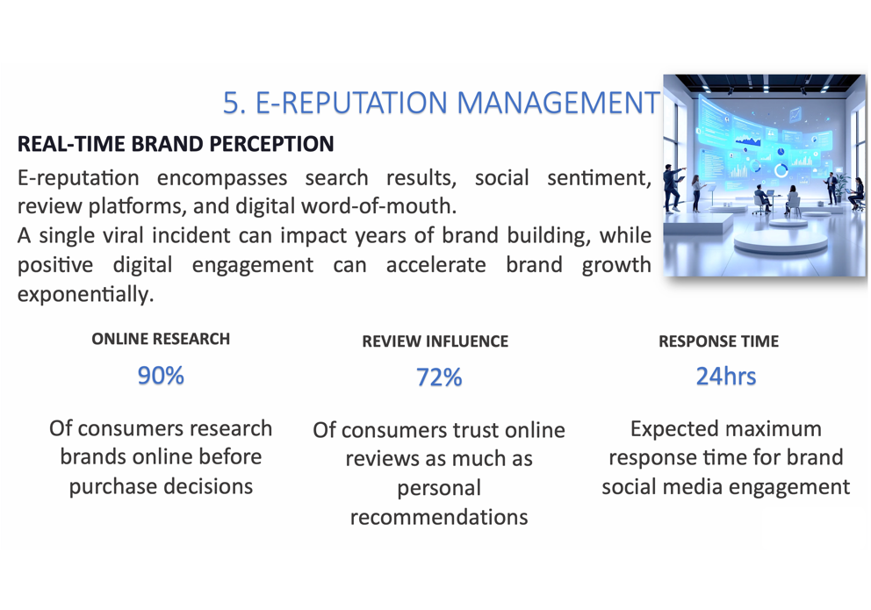

- Integrated brand management framework
- Lifecycle management : sustain brand relevance over time
- Architecture design : clarify identity and hierarchy
- Portfolio optimization : maximize synergy and reduce overlap
- E-reputation : maintain trust and engagement online

This is called modern brand management : authentic agile and digital
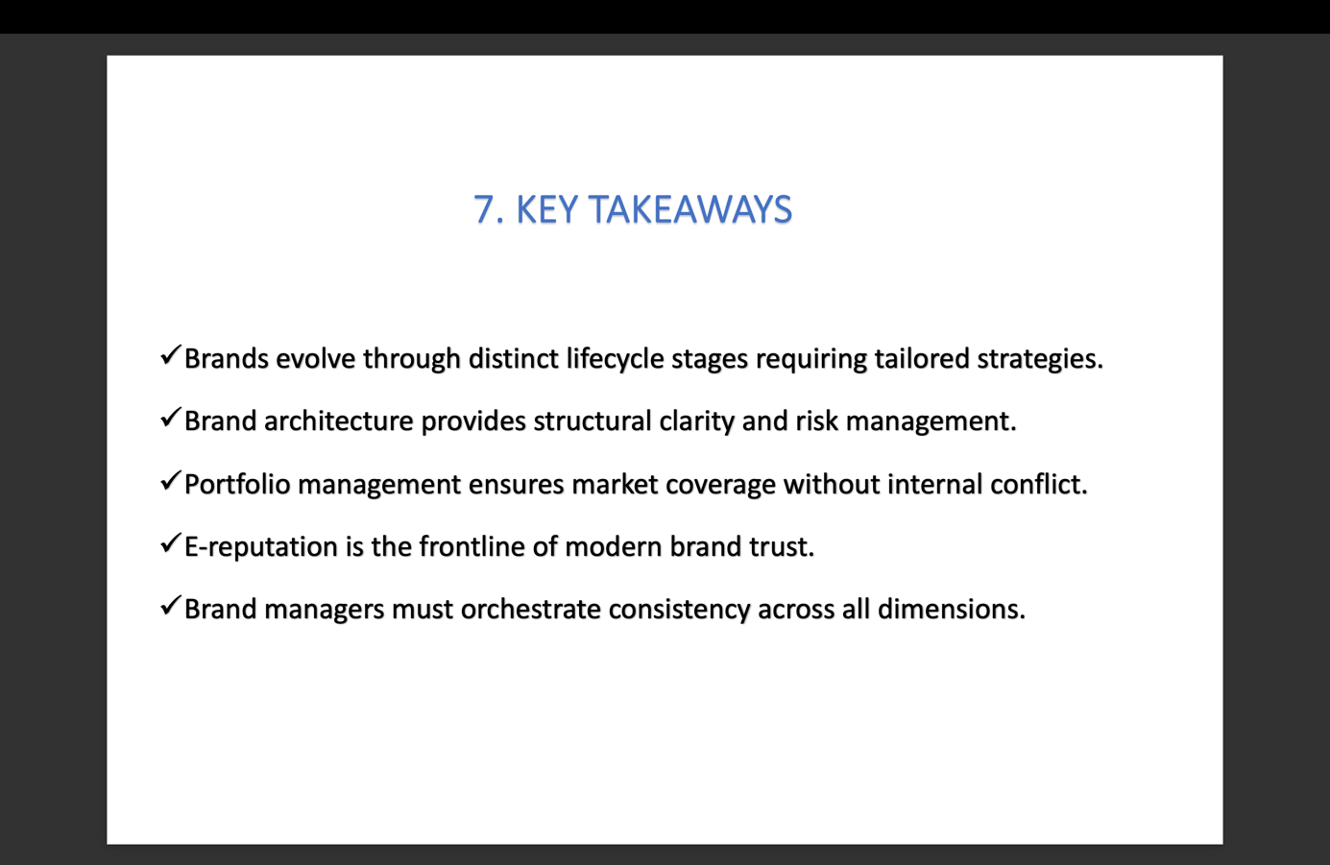

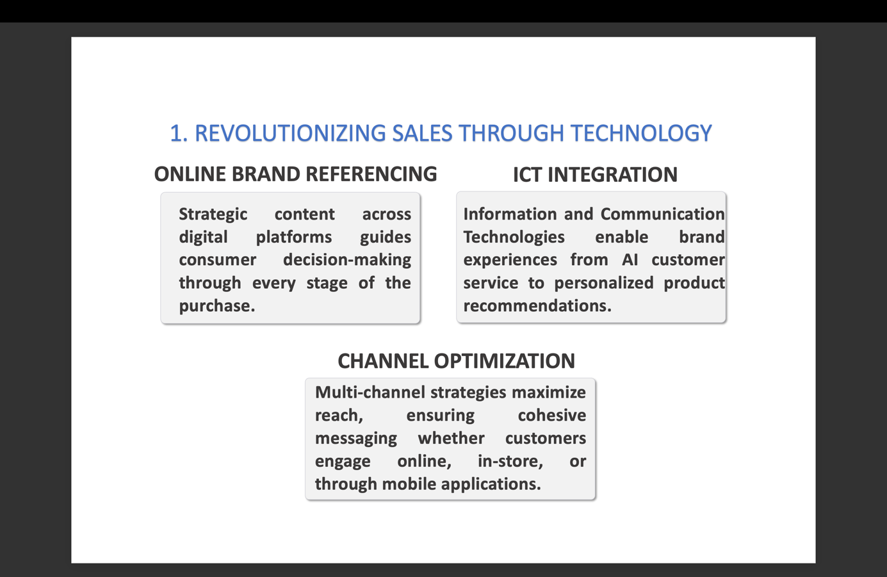

k

